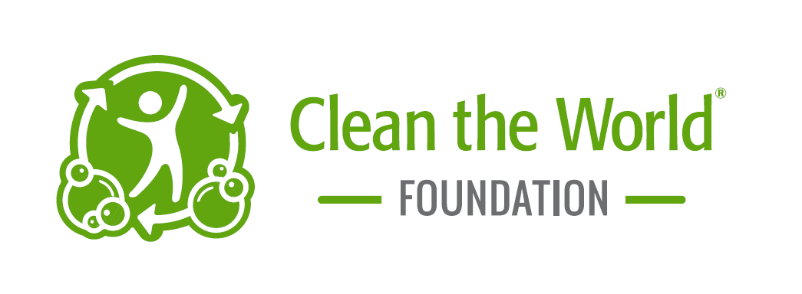
APPLICATION FOR SOAP PRODUCTS
Date of Request: |  |  |  |  | Date Donation is Needed:
*30 day notice required
Contact Information please print
Name (First and Last):
Title:
Organization Name:
Mailing Address:
City, State, Zip Code:
Phone Number:
Email Address:
EIN # |  |  |  |  |  |  | Is your organization a 501(c)3? ☐Yes ☐No

Please Complete the Following Questionnaire

In what geographic area will the product be distributed? |  |  | City: |  |  | State:
Country: |  | Village/Community:

Describe the population that will be receiving the donated product, and how many people will be served.

Describe the programing in which the soap will be used:

Please describe when and how often this program will take place:

For how long will this program last?

Please identify the venue(s) in which the product will be distributed to the population:
☐Clinic/Health Program  ☐Community Gathering/Center  ☐Disaster/Emergency Relief  ☐Faith-Based Program/Church |  | ☐Food Bank/Food Pantry  ☐Nutrition/Feeding Program  ☐Hygiene/Hand Wash Promotion  ☐Maternity/Child Mortality Program | ☐School/Classroom-Based Program  ☐Sanitation Program  ☐Shelters  ☐Water Program
☐Other (please describe):

Please list the Quantity of Items needed: 1 box of soap: 116 bars 1 pallet of soap: 5,452 bars
1 box of bottles: 100 bottles per box

______ Number of soap boxes ______ Number of soap pallets _____ Number of boxes, shampoo bottles
______ Number of boxes, body wash bottles ______ Number of boxes, conditioner bottles

Can your organization arrange shipping from our facility to its destination? ☐Yes ☐No
For convenience, please provide address of the shipping destination, if different from the mailing address:
Shipping Address:
City, State, Zip Code:

Are you able to accommodate a site visit from Clean the World Foundation before or during distribution of the donated soap product? ☐Yes ☐No

By taking this shipment of hygiene products, I agree to fill out a follow up report every 90 days on distribution detailing the number of people served and provide photos and stories for our reporting. ☐ I agree

NOTICE: Donated products must be given away free of charge to the end recipient, without discrimination on the basis of race, color, national origin, age, disability, sex, gender identity, or religion. Donated products cannot be sold, traded, bartered, given to volunteers or staff as gifts, distributed in any fundraising or promotional activities such as raffles, door prizes, auctions, etc. Donated products cannot be used for private, public or political solicitation, or as a condition of participating in religious activities.

Signature: |  | Date:

SEND COMPLETED REQUEST FORM TO: | Clean the World Foundation  Attention: Soap Donation Request  2544 E Landstreet Rd. Suite 600, Orlando FL 32824  Email: gnorris@cleantheworld.org  Fax: (732) 847-5446  For further inquiries, please email or call (407) 574-8353 x 1009

